iStick Update manual

iStick Update manual：

- System requirement Windows XP/7

- Update Tool：iStick_31_V010_1.exe

- Update for downloading tool kit ，find upgrade tool“iStickPro_31_V010_1.exe ”；

- Click Update F/W，initial as below：

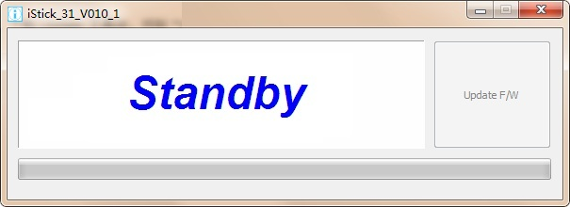

- Insert iStick , tool will auto-detect then click “Update F/W” bottom for upgrade as below ：

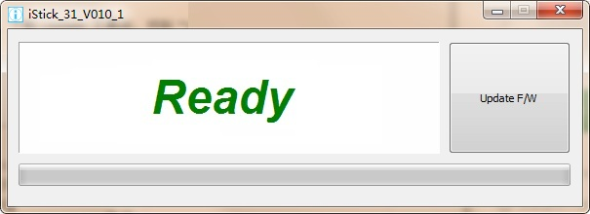

- When upgrade rolling, you will find notice ‘’updating…’’ and show progress percentage from Green bar, please be patient for processing

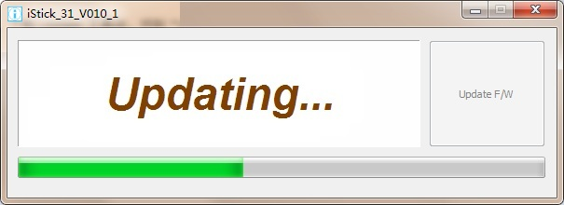

7、When upgrade finish then you will find notice “Update complete ! ‘’as below：

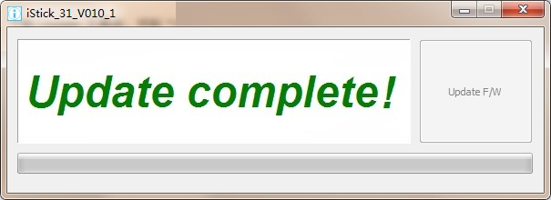

8、Please do not unplug iStick, when you are processing upgrade F/W. Normally will take 15 minutes to complete upgrade F/W. If you can’t work smooth and successful, please try again. If you still can not upgrade F/W after few trying, please contact our local agency

